Study Island 2014 - 2015

Dear Grade 8 Students and Parents,

This spring, Grade 8 students in Massachusetts, including our students at HMS, will take the annual Science MCAS exam, scheduled for May 2015. The Grade 8 Science MCAS exam is a cumulative test, assessing all science concepts studied in Grades 6-8. Given the cumulative nature of the test, Grade 8 students spend some time each spring reviewing previously learned concepts and practicing test questions.

This year, as in past, to support students in their MCAS review, we will be using an on-line study tool known as “Study Island.” Study Island features subject specific lessons, which include sample test questions and games to engage students in review of content. This week, all Grade 8 students will complete a Study Island orientation and pre-test. In subsequent weeks, students will complete lessons independently as part of their routine homework assignments.

Study Island is completely web-based, which allows students to access the program from any computer with Internet connection and standard web browser. Each student will have an individual log-in and password (in most cases identical to their HMS computer log-in) and may access their Study Island account both at home and in school. If a student does not have regular access to a computer at home, printed worksheets will be available as an alternative.

Additional review materials and resources will be available to students via the Grade 8 Science web-page, accessed through the Hingham Public Schools website. If you have any questions, feel free to contact our K-12 Science Director, Katie Roberts, at kroberts@hinghamschools.com, or your child’s classroom teacher.

We thank you for your support of this program!

Regards,

Katie Roberts Mr. Wachtelhausen, Mrs. Messina, Mrs. Cassidy & Ms. Welch
K-12 Science Director Grade 8 Science Teachers

Using Study Island From Home:

- Go to www.studyisland.com.
- Enter your username and password, and click “Submit.” Your username and password is identical to your HMS computer log-in.
- Click on My Class. Select the green + sign to access posted assignments.
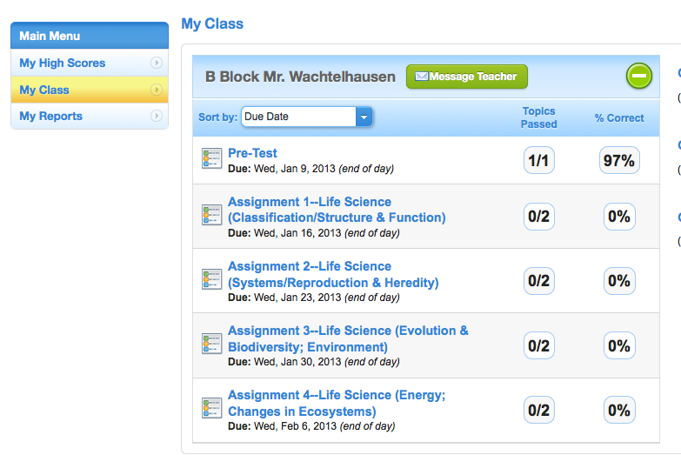

- Select the assignment to be completed, then select the green “Start Studying” tab.
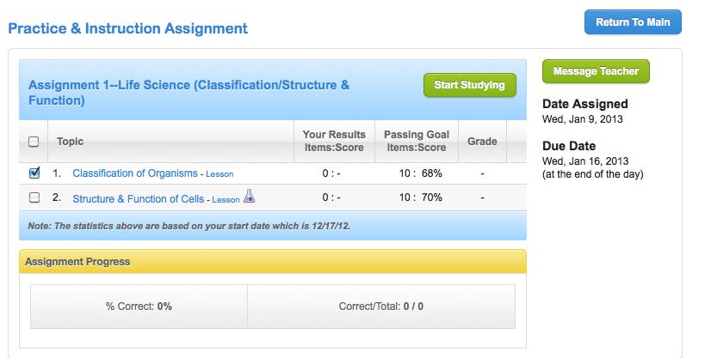

- Select the maximum number of questions, then click “next.”

