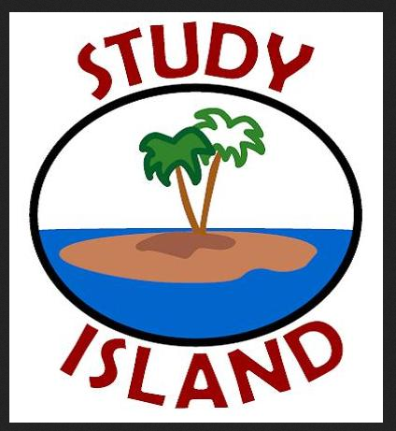 Study Island Lesson Calendar 2014-2015/Mrs. Messina

This note is just a quick explanation of our department and my specific class expectations for Study Island. The weekly assignments will be posted on our class website, on the weekly homework sheet, and in the classroom along with our regular homework assignments. The work window for each session is one week beginning and ending on Wednesdays. Students are expected to complete their Study Island session assignment by the end of the day on the posted due date, outside of class on their own time, as part of their weekly assignments. We are looking for a 70% correct result in order to receive a 100 for the homework grade. Results will be entered in X2 just like any other homework assignment. At the end of the Study Island sessions, students will receive an additional test grade in their term average based on the timely and accurate completion of the assignments (Term 4).

The following schedule will run from December up to MCAS in May:

Topic | Calendar:
Assignment 1: (Life Science)  Classification of Organisms  Structure & Function of Living Things | Assigned:  Orientation in HMS Computer Lab week of Dec. 8 | Due:  Wednesday 12/17
Assignment 2: (Life Science)  Systems in Living Things  Reproduction & Heredity | Assigned:  Wednesday 1/7 | Due:  Wednesday 1/14
Assignment 3: (Life Science)  Evolution & Biodiversity  Living Things & Their Environment | Assigned:  Wednesday 1/14 | Due:  Wednesday 1/21
Assignment 4: (Life Science)  Energy & Living Things  Changes in Ecosystems | Assigned:  Wednesday 1/21 | Due:  Wednesday 1/28
Technology & Engineering Mini-Unit--February 2-13th
Intro to Engineering Design Process
Design Challenge
Open Response Practice

Assignment 5: (Tech & Engineering)  Materials, Tools & Machines  Engineering Design | Assigned:  Wednesday 1/28  Assigned:  Wednesday 2/4 | Due:  Wednesday 2/4  Due:  Wednesday 2/11
Assignment 6: (Tech & Engineering)
Communications & Manufacturing Tech; Impact of Science

Assignment 7: (Physical Science)  Properties of Matter  Elements, Compounds & Mixtures  Physical & Chemical Changes | Assigned:  Wednesday 2/25 | Due:  Wednesday 3/4
Assignment 8: (Physical Science)  Motions of Objects  Heat Energy | Assigned:  Wednesday 3/4 | Due:  Wednesday 3/11
Assignment 9: (Earth Science)  Mapping the Earth  Earth’s Structure | Assigned:  Wednesday 3/11 | Due:  Wednesday 3/18
Assignment 10: (Earth Science)  Heat Transfer in the Earth  Earth’s History | Assigned:  Wednesday 3/18 | Due:  Wednesday 3/25
Assignment 11: (Earth Science)  The Earth in the Solar System | Assigned:  Wednesday 3/25 | Due:  Wednesday 4/1
POST TEST | Assigned:  TBD | Due  TBD
PRACTICE TEST: Friday, April 10th (In Class)

APRIL VACATION: 4/20-4/24

Gr. 8 Science MCAS
2 days during 2nd or 3rd week of May

